|  |
| --- |
| FACULTY OF ENGINEERING & TECHNOLOGY BACHELOR OF TECHNOLOGY  (303105152) Design Thinking  II SEMESTER  ARTIFICIAL INTELLIGENCE & MACHINE LEARNING  DEPARTMENT |
| Laboratory Manual |
|  |

**CERTIFICATE**



|  |
| --- |
| *This is to certify that*  *Mr./MS* *with enrolment no.*  *has successfully completed his/her laboratory experiments in the(303105152) Design Thinking from the department of*  *........................................................... during the academic year ........................*    Date of Submission: ......................... Staff in charge: ...........................  Head of Department: ........................................... |

|  |  |  |  |  |  |  |  |  |  |
| --- | --- | --- | --- | --- | --- | --- | --- | --- | --- |
|  | **Class: II SEM**  AY: 2024‐2025 | **INDEX** | **Faculty of Engineering and Technology**  **(303105152)**  **SUBJECT: DESIGN THINKING**  SUBJECT CODE: 303105152 | | | | | | |
| **Sr no** | **Experiment Title** | | **Page no** | | **Date of perfor mance** | **Date of assessm ent** | **Marks out of 10** | **Sign** |  |
|  |  | | **Fr om** | **To** |  |  |  |  |
| **1** | **Introduction to design thinking:**  Introduce the concept of design thinking, its benefits, and | |  |  |  |  |  |  |
|  | the overall process. | |
| **2** | **Empathy mapping exercise:**  Have participants conduct interviews with potential users | |  |  |  |  |  |  |
|  | and create empathy maps to gain a deeper understanding | |
|  | of their needs, wants, and pain points. | |
| **3** | **Define the problem statement:**  Based on the empathy mapping exercise, have participants | |  |  |  |  |  |  |
|  | synthesize their findings and define a problem statement. | |
| **4** | **Ideation session:**  Have participants generate as many ideas as possible to | |  |  |  |  |  |  |
|  | solve the problem statement. Encourage wild, | |
|  | unconventional, and innovative ideas. | |
| **5** | **Prototyping session:**  Have participants select one or more ideas and create a | |  |  |  |  |  |  |
|  | low‐fidelity prototype to test their assumptions and | |
|  | validate their ideas. | |
| **6** | **Testing and feedback session:**  Have participants test their prototypes with potential | |  |  |  |  |  |  |
|  | users and gather feedback on what works, what doesn't, | |
|  | and what could be improved. | |
| **7** | **Refine and iterate on prototype:**  Based on the feedback, have participants refine and | |  |  |  |  |  |  |
|  | iterate on their prototype to improve its usability, | |
|  | functionality, and appeal. | |
| **8** | **Presentation of final prototype:**  Have participants present their final prototype to the rest | |  |  |  |  |  |  |
|  | of the group, explaining their design decisions, insights, | |
|  | and learnings. | |
|  | Enrollment No: 2403031460001 |  |  |  |  |  | Page No: 1 | |  |

# PRACTICAL 1



## AIM: Introduction to design thinking:

Introduce the concept of design thinking, its benefits, and the overall process

## INTRODUCTION TO CONCEPTS OF DESIGN THINKING

Design Thinking is a human‐centered approach to innovation and problem‐solving that emphasizes creativity, collaboration, and empathy. It is widely used across industries to develop user‐focused solutions to complex challenges. Originating from the practices of designers, this methodology has expanded into fields such as business, education, healthcare, and technology.

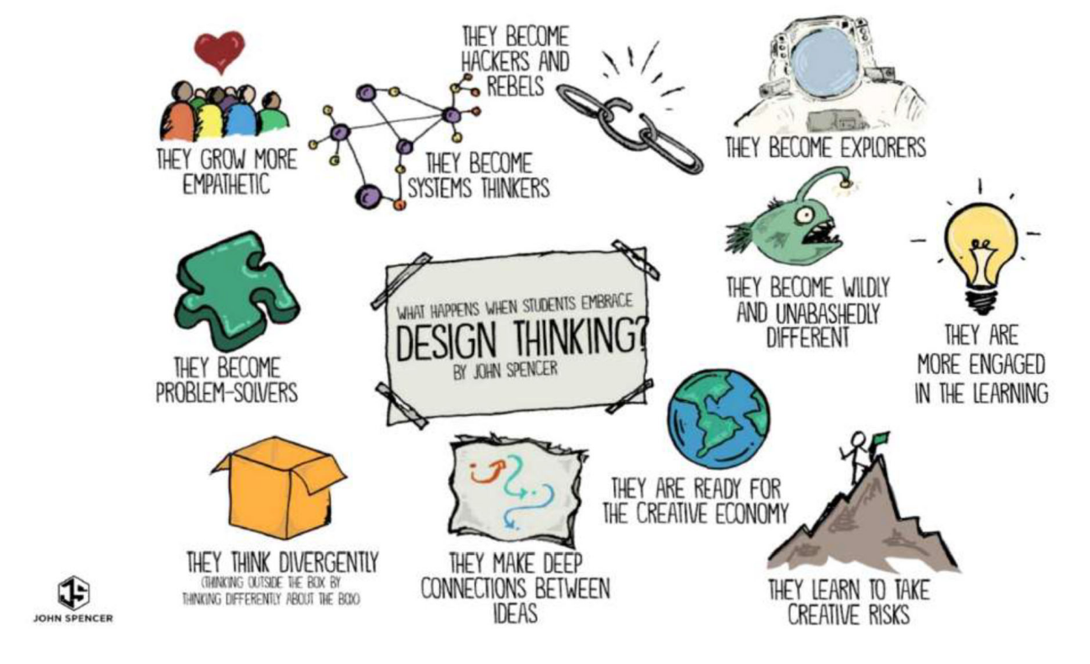

## Key Features of Design Thinking

1. **Human‐Centered:** The process revolves around understanding the needs, behaviors, and emotions of the people for whom the solution is being designed.
2. **Iterative Process:** Design Thinking is non‐linear, encouraging continuous refinement of ideas through testing and feedback.
3. **Collaboration:** It brings together diverse perspectives to foster innovation.
4. **Creativity:** It promotes thinking outside traditional frameworks to generate fresh, imaginative solutions.



Design Thinking is an iterative process that empowers individuals and teams to approach problems with a creative and user‐centered mindset. It emphasizes understanding the needs of users, challenging existing assumptions, and reimagining solutions through experimentation and prototyping. By fostering empathy, collaboration, and innovation, Design Thinking encourages a culture of adaptability and continuous improvement.

This process empowers participants by:

* + **Focusing on the user:** Prioritizing the needs and experiences of the end‐user ensures solutions are relevant and impactful.
  + **Encouraging creativity:** Open ideation sessions inspire diverse ideas and innovative approaches.
  + **Promoting collaboration:** Cross‐functional teamwork brings varied perspectives to the table, enhancing problem‐solving capabilities.
  + **Minimizing risks:** Testing prototypes early allows teams to learn quickly and refine solutions without significant investments.
  + **Driving change:** By rethinking conventional practices, Design Thinking enables organizations to adapt to evolving challenges and opportunities.

Ultimately, Design Thinking empowers individuals to not only address immediate challenges but also to cultivate a mindset that values learning, experimentation, and empathy in all aspects of problem‐solving.

## The Five Phases of Design Thinking

1. **Empathize:** Gain deep insights into the users' needs and challenges by conducting interviews, observations, and research.
2. **Define:** Synthesize findings from the empathize phase to articulate a clear problem statement or point of view (POV).
3. **Ideate:** Brainstorm and explore a wide range of creative solutions without judgment.
4. **Prototype:** Build simple, tangible representations of ideas to test their feasibility and usability.
5. **Test:** Gather feedback by presenting prototypes to users, iterating based on their input to refine the solution.

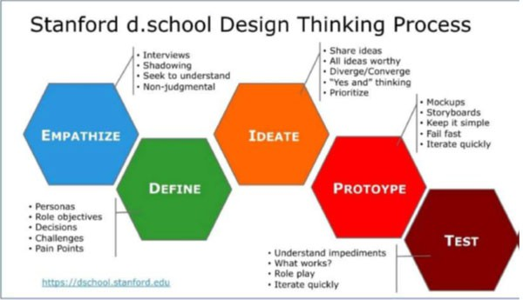

The essence of Design Thinking lies in its **human‐centered approach** to innovation and problem‐solving. It focuses on understanding and addressing the needs of people to create meaningful and effective solutions. Key aspects that capture the essence of Design Thinking include:

1. **Empathy:** Deep understanding of the users’ experiences, emotions, and needs forms the foundation of the process.
2. **Problem Reframing:** Challenging assumptions and redefining problems ensures solutions address the core issues.
3. **Creativity and Innovation:** Encouraging out‐of‐the‐box thinking to generate novel ideas and solutions.
4. **Collaboration:** Bringing together diverse perspectives fosters richer insights and more holistic solutions.

## Applications of Design Thinking

Design Thinking is a versatile methodology that can be applied across various domains and industries to address diverse challenges. Some notable applications include:

## Product Design and Development:

* + Creating user‐friendly and innovative products that meet customer needs.
  + Examples: Designing intuitive apps, consumer electronics, or healthcare devices.

## Service Design:

* + Enhancing customer experiences by redesigning services.
  + Examples: Streamlining hotel check‐ins, optimizing banking services, or improving public transportation systems.

## Business Strategy:

* + Identifying new business opportunities and refining organizational processes.
  + Examples: Developing customer‐centric business models or improving employee workflows.



## Healthcare:

* + Addressing patient care challenges by designing empathetic solutions.
  + Examples: Simplifying medical device interfaces or improving hospital layouts for efficiency.

## Education:

* + Redesigning curriculums and learning environments to enhance student engagement.
  + Examples: Creating innovative teaching tools or designing collaborative classroom spaces.

## Social Innovation:

* + Tackling complex societal challenges such as poverty, climate change, and access to clean water.
  + Examples: Developing affordable housing solutions or sustainable farming techniques.

## Technology:

* + Building user‐centered digital experiences.
  + Examples: Enhancing usability of websites, apps, and software platforms.

## Benefits of Design Thinking

1. **Enhanced Innovation:**
   * Fosters creativity by encouraging diverse perspectives and out‐of‐the‐box thinking.

## User‐Centered Solutions:

* + Focuses on understanding and addressing user needs, ensuring relevance and effectiveness.

## Risk Reduction:

* + Early prototyping and testing help identify flaws and gather feedback, reducing the cost of failures.

## Improved Collaboration:

* + Encourages teamwork across disciplines, leading to holistic solutions.

## Faster Problem‐Solving:

* + Iterative processes accelerate learning and solution development.

## Adaptability:

* + Promotes a culture of continuous learning and adaptability to changing circumstances.

## Competitive Advantage:

* + Businesses leveraging Design Thinking can differentiate themselves by offering superior customer experiences and innovative products.

## Empowerment and Engagement:

* + Teams feel more invested and motivated through collaborative, creative processes.

Design Thinking's combination of empathy, creativity, and practicality makes it a powerful tool for addressing both organizational and societal challenges.



**Design** and **Design Thinking** are closely related concepts, but they represent different approaches and scopes of work. **Here’s a contrast between them:**

|  |  |  |
| --- | --- | --- |
| **Aspect** | **Design** | **Design Thinking** |
| **Definition** | Design refers to the act of creating and planning aesthetic, functional, or technical solutions for products, services, or systems. It is often centered around a specific solution. | Design Thinking is a human‐centered problem‐solving methodology that involves understanding users, ideating, prototyping, and testing ideas iteratively to arrive at solutions. |
| **Focus** | Focuses on the creation and aesthetics of the end product or solution. | Focuses on the process of problem‐ solving and innovation, with a heavy emphasis on empathy and user needs. |
| **Scope** | Primarily concerned with the visual, functional, and practical aspects of a product or service. | Encompasses the entire process of identifying a problem, ideating, prototyping, testing, and refining to achieve a human‐centered solution. |
| **Approach** | Can be linear, aiming at a final product with specific design goals. | Iterative, with a focus on continuous learning, testing, and improving solutions. |
| **Outcome** | The end result is often a final product, system, or service that meets design specifications. | The outcome is an iterative process that leads to a refined solution or prototype, often evolving over time. |
| **Tools and Techniques** | Includes graphic design, industrial design, UI/UX design, and other specialized techniques. | Involves empathy‐building, brainstorming, prototyping, and testing to explore diverse solutions. |
| **Goal** | To create a tangible product or solution that meets specific requirements. | To create innovative solutions based on user insights, while also learning and iterating throughout the process. |

## Differentiating Design and Design Thinking:

1. **Orientation:**
   * **Design:** Focused on **creating** something tangible, like a product, graphic, or space, with emphasis on aesthetics and functionality.
   * **Design Thinking:** A **problem‐solving methodology** that focuses on understanding the people you're designing for, generating creative solutions, and iterating on them.



## Process:

* + **Design:** Often a **linear** process that begins with a concept and moves toward a finalized product or solution.
  + **Design Thinking:** An **iterative** process that moves back and forth between different phases like empathy, ideation, and testing to refine solutions continuously.

## Problem‐Solving Approach:

* + **Design:** Focuses on solving a **specific design problem** (e.g., creating an efficient chair, designing a logo).
  + **Design Thinking:** Aims to solve **complex, open‐ended problems** (e.g., improving customer experience, designing a service) by understanding the underlying issues, needs, and context.

## Human‐Centeredness:

* + **Design:** While design can consider users, it may not always prioritize **deep empathy** with the end‐user.
  + **Design Thinking:** Puts **human empathy** at the core, seeking to deeply understand users' emotions, behaviors, and pain points before creating a solution.

## Flexibility and Adaptability:

* + **Design:** Once a solution is reached, it tends to be **finalized**, often with little revision unless there’s a problem.
  + **Design Thinking:** Promotes **continuous refinement**, with prototypes and ideas evolving based on feedback and testing.

## Mindset:

* + **Design:** A more traditional and specialized skill, focused on applying knowledge to create specific products.
  + **Design Thinking:** A mindset and approach that can be applied by anyone in any field, not limited to designers, to foster innovation and solve problems creatively.

## Iterative and Collaborative:

* + **Design:** Follows more linear and individualistic approach
  + **Design Thinking:** Involves iterative and collaborative process.

## Summary:

* **Design** is about **creating** and making things look or function in a certain way, focusing on the **end result**.
* **Design Thinking** is about the **process** of approaching problems creatively and iteratively, involving **empathy** and user‐centered solutions. It goes beyond aesthetics to explore how to solve problems effectively for the people it affects.



## Complementary Relationship:

1. **Synergy in Innovation:** Design and Design thinking are not mutually exclusive; they can complement each other to drive holistic innovation, combining the aesthetic and functional aspects with user‐centric problem‐solving.
2. **Integration in Product Development:** By integrating Design Thinking into the design process, organizations can create products that are not only visually appealing but also deeply resonate with users’ needs and experiences.
3. **Balancing Creativity and Practicality:** The fusion of design and design thinking allows for the harmonious integration of creative expression with the pragmatic focus on addressing real‐world challenges.

## Holistic Design and Design Thinking:

1. **Holistic Design Strategies:** Organizations can leverage both design and design thinking to develop comprehensive strategies that encompass aesthetic appeal, functional excellence and user centric approach.
2. **Cultivating a Culture of Innovation:** By embracing both design and design thinking, companies can foster a culture that values creativity, empathy and continuous improvement driving sustained innovation.
3. **Market Differentiation:** The integration of design and design thinking in the design process can lead to the creation of products and experiences that stand out in the market, resonating deeply with users.

## Navigating the Design Thinking Process:

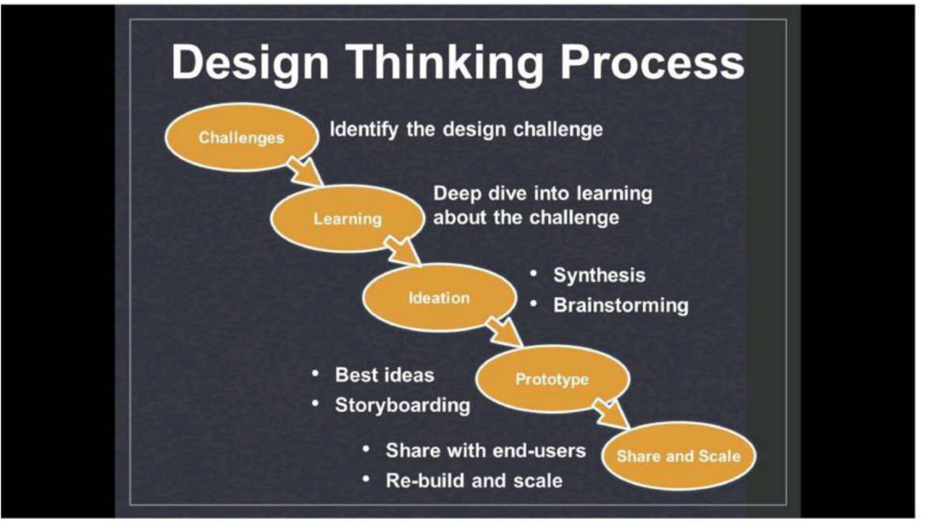



1. **Empathize**
   * **Goal**: Understand the user’s needs, emotions, and challenges.

## Actions:

* + - Conduct interviews, surveys, and observations to gather insights.
    - Create empathy maps to visualize user experiences.
    - Immerse yourself in the user’s environment to gain a first‐hand perspective.

**Key Outcome**: A deep understanding of the user's context and pain points.

## Define

* + **Goal**: Clearly articulate the problem based on user insights.

## Actions:

* + - Synthesize research findings into themes and patterns.
    - Craft a user‐centered problem statement, often called a "Point of View (POV)."
    - Use tools like "How Might We" questions to reframe challenges into opportunities.

**Key Outcome**: A focused problem statement that guides the next stages.

## Ideate

* + **Goal**: Generate a wide range of creative ideas to address the problem.

## Actions:

* + - Facilitate brainstorming sessions to encourage divergent thinking.
    - Use techniques like mind mapping, SCAMPER, or role‐playing to spark creativity.
    - Prioritize ideas through voting, grouping, or feasibility assessments.

**Key Outcome**: A pool of potential solutions, with a few prioritized for prototyping.

## Prototype

* + **Goal**: Create simple, low‐cost representations of ideas to test their viability.

## Actions:

* + - Build mockups, sketches, digital wireframes, or physical models.
    - Focus on rapid development to explore various concepts.
    - Prepare prototypes to simulate the user experience or specific functionalities.

**Key Outcome**: Tangible prototypes ready for user feedback and testing.

## Test

* + **Goal**: Evaluate prototypes by observing how users interact with them.

## Actions:

* + - Conduct usability testing sessions to gather feedback.
    - Identify what works, what doesn’t, and what can be improved.



* + - Iterate and refine prototypes based on insights from testing.

**Key Outcome**: Improved solutions that are closer to meeting user needs effectively.

## Implement (Beyond the Core Process)

* + **Goal**: Scale the solution into a final product or service.

## Actions:

* + - Transition prototypes into production‐ready solutions.
    - Align stakeholders, resources, and timelines for rollout.
    - Monitor real‐world performance and continue iterating as necessary.

**Key Outcome**: A fully realized solution that delivers measurable value to users.

## Tips for Successful Navigation

* + **Iterate Frequently**: View each phase as flexible and return to earlier steps if needed.
  + **Collaborate Actively**: Engage diverse perspectives to uncover richer insights and solutions.
  + **Stay User‐Centric**: Regularly validate ideas and prototypes with actual users.
  + **Balance Creativity and Feasibility**: Encourage bold ideas but ground them in practical considerations.

## Conclusion

Navigating the design thinking process is about embracing ambiguity, maintaining empathy, and continuously iterating toward a solution that resonates deeply with users. By following these steps, individuals and teams can transform complex challenges into innovative opportunities.

# PRACTICAL 2



## AIM: Empathy mapping exercise:

Have participants conduct interviews with potential users and create empathy maps to gain a deeper understanding of their needs, wants, and pain points.

## Introduction:

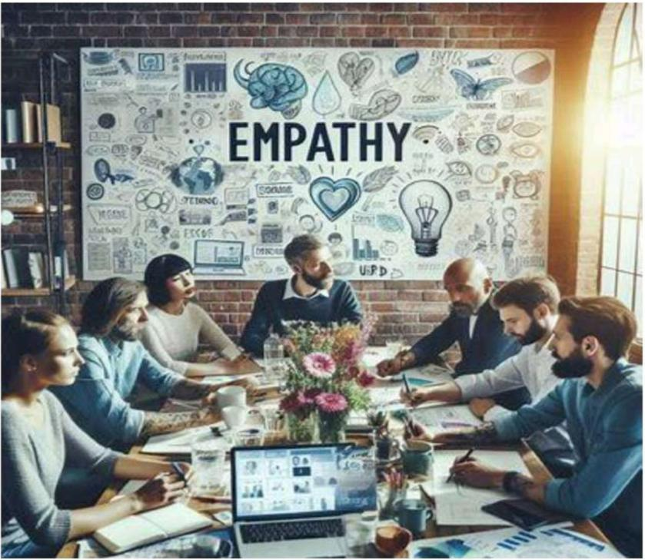**Empathy** is the ability to understand and share the feelings, perspectives, and experiences of others. It goes beyond mere sympathy by fostering a deep connection to another person’s emotional and cognitive world. Empathy is a cornerstone of human‐ centered approaches, such as **design thinking**, where understanding users' needs and experiences is paramount to creating meaningful and effective solutions.

## Understanding Empathy in Design Thinking:

**Importance of Empathy:**

* + **Enhanced Understanding:** Empathy is the cornerstone of design thinking, enabling designers to gain a deep understanding of users’ needs, desire and challenges.
  + **Human Centered Solutions:** Empathy allows for a deep understanding of people's needs, desires, and pain points. It ensures that solutions are designed to genuinely address user challenges, making them more effective and impactful.
  + **Improved user experience:** Designing with empathy leads to products and services that resonate with users on emotional level, resulting in a more positive and meaningful user experience.



## Empathy in the Design Process:

* + **User‐Centric Approach:** Empathy ensures that the design process is focused on the end user, allowing designers to step into the shoes of the people they are designing for.
  + **Problem Identification:** Through empathy designers can identify and define the real problems and pain point experienced by the users, laying the foundation for effective problem‐solving.
  + **Iterative Design:** Empathy encourages an iterative approach to design, where feedback from users is valued and incorporated into the design process, leading to continuous improvement.

## Empathy Impact on Innovation:

* + **Inspiring Creativity:** Empathy fuels creativity by inspiring designers to think beyond their own perspectives and consider a wide range of user experience and solutions.
  + **Humanizing Technology:** By integrating empathy into the design of technology, products and services become more human‐centered, fostering a stronger connection between users and technology.
  + **Market Relevance**: Empathic design leads to products and services that are more relevant to the market, as they are tailored to meet genuine user needs and aspirations.

## Case Studies:

* + **Apple's Design Philosophy**: Apple’s design philosophy is rooted in empathy, ensuring that products are intuitive, functional, and emotionally resonant with users. By deeply understanding users’ needs, behaviors, and challenges, Apple creates designs that feel natural and personal, offering seamless experiences that prioritize ease of use and emotional connection.
  + **Airbnb's User‐Centric Model**: Airbnb places users at the heart of its platform, ensuring both hosts and guests have personalized and frictionless experiences. By continuously gathering feedback and iterating on design, Airbnb ensures its service feels welcoming, accessible, and intuitive for diverse users.
  + **IDEO's Human‐Centered Solutions**: IDEO uses human‐centered design to create innovative products and services by deeply understanding users' needs, motivations, and challenges. They emphasize empathy in their process, enabling solutions that are both functional and emotionally



## Techniques for Empathy Research:

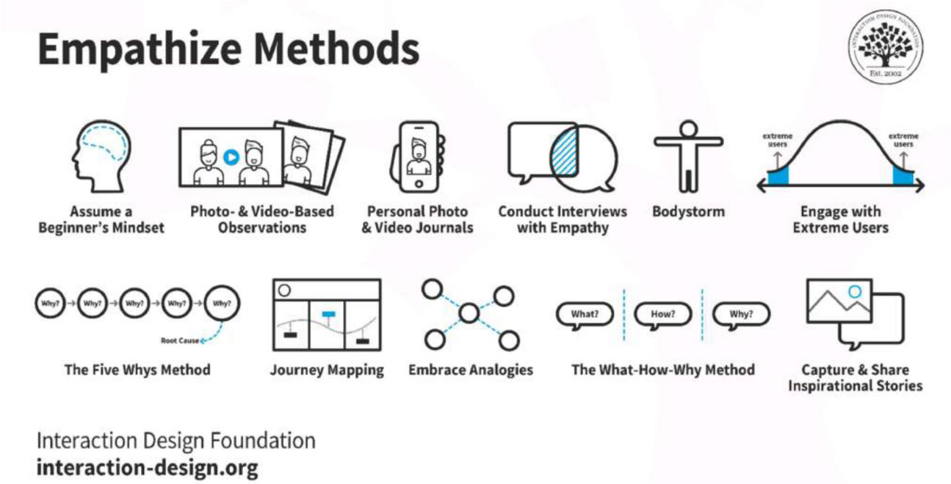

1. **User Interviews**
   * **In‐Depth Conversations**: Conducting detailed discussions with users to uncover their emotions, motivations, and pain points.
   * **Empathy Mapping**: Visualizing user experiences through charts that capture what users say, think, feel, and do to better understand their perspective.
   * **Contextual Inquiry**: Observing users in their natural environment while asking questions to gain insights into their behaviors and experiences.

## Immersion and Observation

* + **Ethnographic Studies**: Immersing oneself in the user's culture and environment to observe and understand their social and daily practices.
  + **Shadowing**: Following users throughout their day to observe their interactions, decision‐making, and challenges in real‐time.
  + **Participatory Design**: Actively involving users in the design process, allowing them to co‐create solutions based on their experiences.

## Empathy Tools and Technologies

* + **Virtual Reality (VR) Simulations**: Using VR to immerse designers in the user’s experience, allowing them to feel firsthand the challenges users face.
  + **Digital Storytelling**: Leveraging multimedia tools to share compelling user stories, offering insights into their emotional journeys.
  + **Empathy Cards and Empathy Prompts**: Tools that guide designers in understanding users’ emotions, needs, and motivations through structured activities and prompts.



## Data Analysis and Synthesis

* + **Empathy Maps**: Organizing qualitative data into a visual format to understand user behaviors, needs, and feelings from multiple perspectives.
  + **Behavior Analytics:** Analyzing user interactions with products and social media sentiment to understand user emotions, preferences, and pain points.
  + **Sentiment Analysis**: Leveraging natural language processing to understand user sentiments expressed in feedback, reviews, and social media.

## Guidelines for Empathetic Research

1. **Cultivating Empathy**
   * **Active Listening**: Focus on understanding the user's perspective by listening attentively without interrupting or leading.
   * **Cultural Sensitivity**: Respect and acknowledge cultural differences, ensuring research practices are inclusive and appropriate for diverse groups.
   * **Empathy Workshops**: Organize sessions where team members practice empathy‐ building techniques to better understand users' needs and emotions.

## Ethical Considerations

* + **Informed Consent**: Ensure participants fully understand the research purpose, methods, and any potential risks before agreeing to participate.
  + **Privacy Protection**: Safeguard sensitive information by obtaining explicit consent and keeping personal data confidential.
  + **Data Security**: Implement strict measures to protect data from unauthorized access, ensuring secure storage and handling of all user information.

## Collaboration and Communication

* + **Interdisciplinary Collaboration**: Engage team members from diverse fields (design, engineering, business) to bring varied perspectives into the research process.
  + **User‐Centric Communication**: Use clear and straightforward language that aligns with users' knowledge and experiences, ensuring they feel heard and understood.
  + **Feedback Integration**: Continuously incorporate user feedback to refine research insights and design decisions, ensuring solutions remain aligned with real user needs.

## Impactful Implementation

* + **Iterative Design Process**: Use a cyclical approach where user feedback is gathered and applied continuously, improving the design with each iteration.
  + **User Validation**: Validate design concepts with real users through testing and feedback to ensure solutions truly address their needs and expectations.
  + **Empathy as a Mindset**: Foster empathy not just as a tool but as a core mindset, ensuring it informs every aspect of the design and decision‐making process.



## Exercise:

AIM: Empathy Mapping Exercise. PROBLEM:

Bluetooth Connectivity Issue

IDEA: Simplify the pairing process with clear step by step instruction. Provide visual aids or tutorials to guide users regarding the pairing process.

Optimize Bluetooth firmware and software to reduce connection drop. Upgrade Bluetooth Hardware.

CONDUCT A NEEDFINDING INTERVIEW:

Ask Open Questions as:

Q. Can you describe a time you encountered these issues?

Q. How did you troubleshoot and resolve?

Q. Command Reasons for this issue?

Q. How would you address them?

Q. How would you improve them?

Q. What strategies would you use to improve the range and signal strength of Bluetooth connections?



|  |  |
| --- | --- |
| ~ “My Bluetooth keeps disconnecting  randomly” | ~ “I wonder if there’s something wrong with  my phone ‘s Bluetooth settings.” |
| ~ “I Can’t pair my phone with the Bluetooth speaker” | ~ “ Why does things always happen when I’m in the middle of something  important?1” |
| ~ “ I always have trouble connecting my  headphones to different devices” | ~ “May be I needed to update my device’s  firmware.” |
| **SAYS** | **THINKS** |
| **DOES** | **FEELS** |
| ~ Tries to reconnect multiple times | ~ “ It’s so annoying when my Bluetooth drop  out.” |
| ~ Searches online for troubleshooting tips | ~ “I’m worried, I won’t be able to connect in  time.” |
| ~ Resets Bluetooth setting on the device | ~ “ I don’t understand why it’s not working,  it was fine yesterday.” |
| **PAIN** | **GAIN** |
| ~ Unreliable connection causing frustration and inconvenience. | ~ When Bluetooth connection works  seamlessly, it enhances the overall user experience. |
| ~ Lack of clear troubleshooting steps from  the device manufacturer. | ~ Convenient wireless connectivity allow  users to enjoy music, make calls, etc |
| ~ Difficulty in connecting to multiple devices  seamlessly. |  |

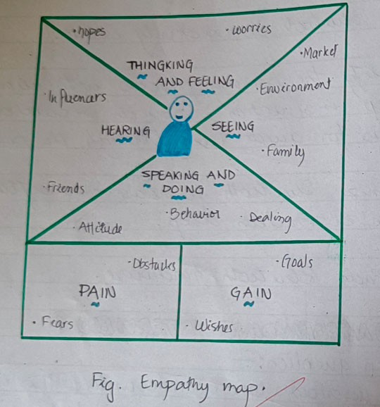

# PRACTICAL 3



## AIM: Define the Problem Statement:

Based on the empathy mapping exercise, have participants synthesize their findings and define a problem statement.

## Explain how POV can be used in defining the design problem?

The **Point of View (POV)** is a crucial step in the design thinking process. It helps frame the problem in a way that is user‐centered, ensuring the design solution is tailored to meet the needs, motivations, and challenges of the target audience. A well‐defined POV statement provides clarity and direction, guiding the design team toward effective and impactful solutions.

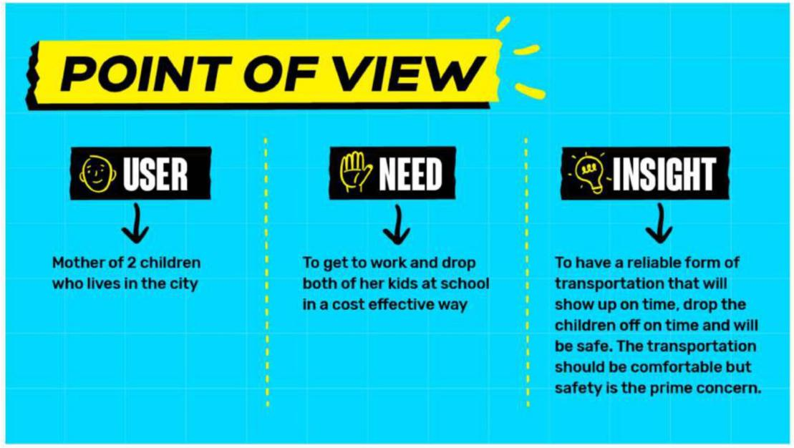

Let’s explore how PoV can be used in defining the design problem using a structured approach

Understanding the PoV What is a PoV?

**Point of View (POV)** is a clear and concise statement that defines a specific user's needs, goals, and insights, providing direction for design solutions. **Importance**: POV aligns the team’s focus on solving real user problems, ensuring the design is grounded in empathy and relevance. **User‐Centric Design**: POV anchors the design process in understanding users' perspectives, ensuring solutions address their actual needs and desires.



***Significance of PoV in Design Thinking:***

**Empathy‐Driven Design**: POV ensures the design is rooted in the user's emotions, needs, and challenges, fostering a deep connection to the target audience. **Problem Framing**: POV helps define and clarify the design problem from the user's perspective, guiding the team towards meaningful solutions. **Iterative Process**: POV serves as a reference point throughout the design process, ensuring continuous alignment with user needs and enabling refined solutions over time.

***Crafting Effective PoV Statement:***

**User Definition**: Clearly identify the target user, their characteristics, and context to ensure the POV is relevant and specific. **Problem Identification**: Define the core problem the user faces, ensuring it is framed from the user's perspective and addresses their needs. **Insight Integration**: Incorporate key insights gained from user research to highlight the underlying motivations or emotional drivers that influence the problem.

***Benefits of PoV in Design:***

**Alignment with User Needs**: POV ensures the design process stays centered on solving real user problems, leading to solutions that resonate with the target audience. **Focused Ideation**: POV provides a clear direction for brainstorming, narrowing down ideas to those that truly address user needs and challenges. **Measurable Outcomes**: POV helps define clear goals, enabling the team to assess and measure the impact of design solutions on user satisfaction and effectiveness.

***Structured Approach to Arrive at PoV***

**User Persona**: Create a detailed representation of the target user, capturing their demographics, behaviors, goals, and challenges to guide the POV. **Empathy Mapping**: Use insights from user research to understand what users say, think, do, and feel, forming the foundation of the POV. **User Interviews**: Conduct in‐depth conversations to gather real‐life stories and insights, uncovering underlying needs and motivations for the POV.

***Problem Identification***

**Problem Exploration**: Delve into understanding the root causes of the problem, ensuring it is framed in a way that aligns with user needs and context. **User Journey Mapping**: Visualize the user's experience step‐by‐step to identify pain points, emotions, and touchpoints that influence their interaction with the product or service. **Stakeholder Alignment**: Involve key stakeholders in the problem definition process to ensure that their perspectives, goals, and constraints are considered in the solution.



***Insight Integration***

**User Research Synthesis**: Consolidate and analyze research data to distill key insights that reveal users' core needs and motivations. **Pattern Recognition**: Identify recurring themes and behaviors across user data to uncover actionable insights for defining the POV. **Collaborative Refinement**: Work with cross‐functional teams to refine insights, ensuring diverse perspectives shape a well‐rounded and impactful POV.

***Application of PoV in Defining Design Problems:***

***User‐Centric Problem Framing:***

* **User‐First Approach**: Frame the problem from the user’s perspective, prioritizing their needs, experiences, and challenges.
* **Clarity and Specificity**: Define the problem in clear, focused terms to avoid ambiguity and ensure actionable solutions.
* **Goal‐Oriented Design**: Align the problem framing with user‐centered goals, ensuring the design process delivers meaningful outcomes.

***Ideation and Solution Generation***

* **PoV as Ideation Compass**: Use the POV to guide brainstorming sessions, ensuring ideas remain aligned with user needs and insights.
* **Divergent Thinking**: Encourage exploring a wide range of creative solutions, inspired by the POV's insights and user challenges.
* **Solution Relevance**: Ensure generated solutions directly address the problem framed in the POV, maintaining a strong user‐centered focus.

***Iterative Design Validation***

* **User Feedback Integration**: Continuously incorporate insights from user feedback to enhance and validate design solutions.
* **Refinement and Realignment**: Iterate on designs to address identified gaps, ensuring they stay aligned with the user's needs and POV.
* **Measurable Impact**: Evaluate solutions against defined goals and user satisfaction metrics to confirm their effectiveness and relevance.

***Continuous PoV Evolution***

* **Adaption to User Dynamics**: Continuously refine the POV to reflect evolving user behaviors, needs, and contexts.
* **Cross‐Functional Adoption**: Foster collaboration across teams to integrate the POV into all stages of the design and development process.
* **Long‐Term Impact**: Ensure the POV drives sustainable and meaningful solutions that remain relevant over time.



**Exercise:**

**TECH – 1: POV TEMPLATE**

|  |  |  |
| --- | --- | --- |
| USER | NEEDS | INSIGHTS |
| As a college student I am encountering frequent Bluetooth connectivity issues (such as pairing failure, connections drops, etc.) | I need a reliable solution to resolve these connectivity issue. Some of needs are improved pairing stability, reduced connection drops, etc. | Resolving these Bluetooth connectivity issues is crucial for ensuring smooth and uninterrupted user experience which in turn enhance overall device  usability. |

**TECH – 2: POV MADLIB**

As a student who used the Bluetooth headphone need a solution that helps to establish stable Bluetooth connections or resolving pairing issues. Understanding the root cause of this issue will improve user experience or enhance device stability.

## TECH – 3: ROOT CAUSE ANALYSIS (5 Whys)

1. Why is there a Bluetooth connectivity issue? Ans: The Bluetooth connection keeps dropping.
2. Why does the Bluetooth connection keep dropping? Ans: The Bluetooth signal strength is weak.
3. Why is the Bluetooth signal weak?

Ans: There is interference from other wireless device.

1. Why is the interference from other wireless device?

Ans: The Bluetooth device is operating on the same frequency as other nearby devices.

1. Why is Bluetooth device operating on the same frequency as other nearby devices?

Ans: The Bluetooth device is not automatically selecting the least congested frequency channel.

# INSIGHTS: Improving the Bluetooth device’s frequency channel selection algorithm could potentially resolve the connectivity issues by reducing interference from other wireless devices.

This analysis helps identify the root cause of the Bluetooth connectivity issues and provides insight into potential solutions.



## TECH 4: 4W AND 1H

1. What is the issue?

Ans: Bluetooth connection keeps dropping

1. Why is the connection dropping? Ans: Due to the weak Bluetooth signal.
2. When does the weak signal occur?

Ans: During the peak usage times or when multiple devices are active.

1. Who is affected by the issues?

Ans: Users of the Bluetooth enabled device.

1. How can this issue be resolved?

Ans: By implementing a frequency channel selection algorithm could potentially resolve the Bluetooth connectivity issues by reducing interference from other wireless devices.

# PRACTICAL 4



## AIM: Ideation Session:

Have participants generate as many ideas as possible to solve the problem statement. Encourage wild, unconventional, and innovative ideas.

## Ideation for Solutions:

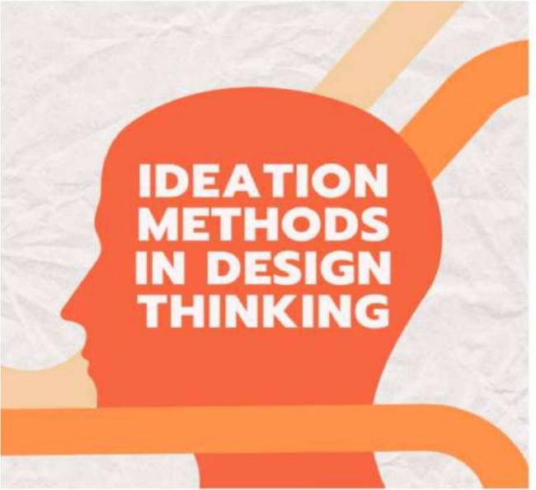**Ideation** is the process of generating, developing, and refining creative ideas to solve a problem or seize an opportunity. It involves brainstorming, exploring possibilities, and thinking innovatively to uncover new solutions or approaches. Ideation can be done individually or collaboratively, often using techniques like mind mapping, sketching, or role‐playing. The goal is to foster creativity and push beyond conventional thinking to discover unique and effective solutions. It’s a crucial step in design thinking, innovation, and problem‐solving frameworks.

***Setting the Stage for Ideation:***

## Understanding the Ideation Process

* + **User Research**: Conduct surveys and interviews to understand user needs, preferences, and pain points.
  + **Expected Outcomes**: Generate innovative, user‐centric solutions that address real problems effectively.
  + **Problem Statement**: Identify a clear, concise challenge to focus ideation efforts, such as, "How can we simplify task management for busy professionals?"

## Creating the Right Environment

* + **Inclusive Participation**: Encourage diverse perspectives by involving individuals from different backgrounds, roles, and expertise.
  + **Silent Brainstorming**: Allow participants to generate ideas independently and quietly, ensuring equal contribution and avoiding group think.
  + **Challenge Questions**: Frame specific, thought‐provoking questions
  + that guide participants toward innovative solutions, such as, "How might we make this process faster and more user‐friendly?"



## Techniques for Idea Generation

* + **How Might We Question**: Use open‐ended "How might we" questions to explore possibilities and inspire creative solutions.
  + **Quantity Over Quality**: Focus on generating as many ideas as possible, embracing all possibilities without immediate judgment.
  + **User‐Centric Approach**: Prioritize the needs, preferences, and experiences of the end‐users in every idea generated.

***Techniques for Idea Evaluation***

## Criteria for Idea Evaluation

* + **Relevance**: Ensure the idea aligns with the problem statement and addresses the core user needs.
  + **Feasibility**: Assess whether the idea can be realistically implemented with available resources and constraints.
  + **Impact**: Evaluate the potential of the idea to create meaningful and positive outcomes for users or stakeholders.

## Evaluation Methods

* + **Voting Systems**: Use group voting to quickly identify and prioritize the most promising ideas based on collective preferences.
  + **SWOT Analysis**: Analyze the Strengths, Weaknesses, Opportunities, and Threats of each idea to determine its strategic viability.
  + **Cost‐Benefit Analysis**: Compare the expected costs and benefits of implementing an idea to assess its overall value and practicality.

## Collaborating Decision Making

* + **Group Discussions**: Facilitate open dialogue to share perspectives and explore ideas collectively.
  + **Consensus Building**: Work toward agreement by aligning team members on the most viable and impactful solutions.
  + **Iterative Refinement**: Continuously improve ideas through feedback, testing, and repeated collaboration.

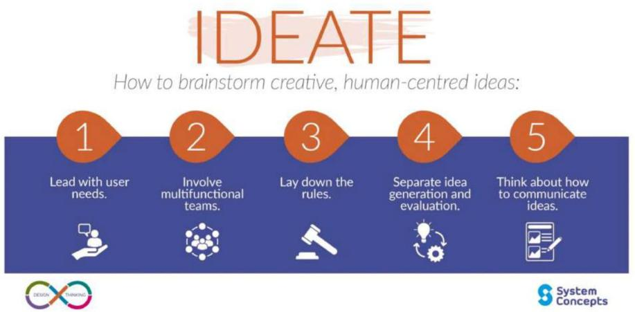



***Prioritizing Ideas for Success***

## Impact Vs Feasibility

* + **Strategic Alignment**: Ensure the idea supports the organization’s long‐ term goals and vision for maximum impact.
  + **Resource Allocation**: Evaluate the availability of necessary resources— time, budget, and talent—to implement the idea effectively.
  + **Risk Assessment**: Identify potential risks and challenges associated with the idea to gauge its feasibility and mitigate issues.

## Implementation Planning

* + **Actionable Roadmap**: Develop a clear, step‐by‐step plan outlining tasks, deadlines, and responsibilities for successful execution.
  + **Stakeholder Engagement**: Involve key stakeholders early and continuously to ensure alignment, support, and feedback throughout the process.
  + **Measurable Outcomes**: Define specific, quantifiable metrics to track progress and assess the success of the implementation.

## Continuous Improvement

* + **Feedback Mechanisms**: Create regular touchpoints for gathering feedback to identify areas for ongoing improvement.
  + **Adaptability**: Encourage a mindset that embraces change and makes swift adjustments based on feedback and evolving needs.
  + **Learning Culture**: Cultivate an environment where continuous learning is valued, and everyone is encouraged to improve through experience and knowledge sharing.



## Exercise:

**IDEATION:** Ideation is the process in design thinking process, where the goal is to generate a diverse range of creative solutions to given problem or challenge.

**BRAINSTORMING:** is a widely recognized ideation technique that encourage the free flow of ideas within a group setting.

* **“Bio inspired Networking “:** Mimic warm intelligence seen in nature for dynamic communication.
* **“Sound Waves “:** Utilizes ultrasonic or infrasonic waves for communication alongside Bluetooth.
* **Telepathic Pairing:** Enable devices to pair based on user intention, bypassing.
* **Quantum Entanglement:** Explore the possibility of instant communication via quantum entanglement.
* **AI – powered Adaption:** Develop AI that learns user behavior to optimize Bluetooth connectivity.

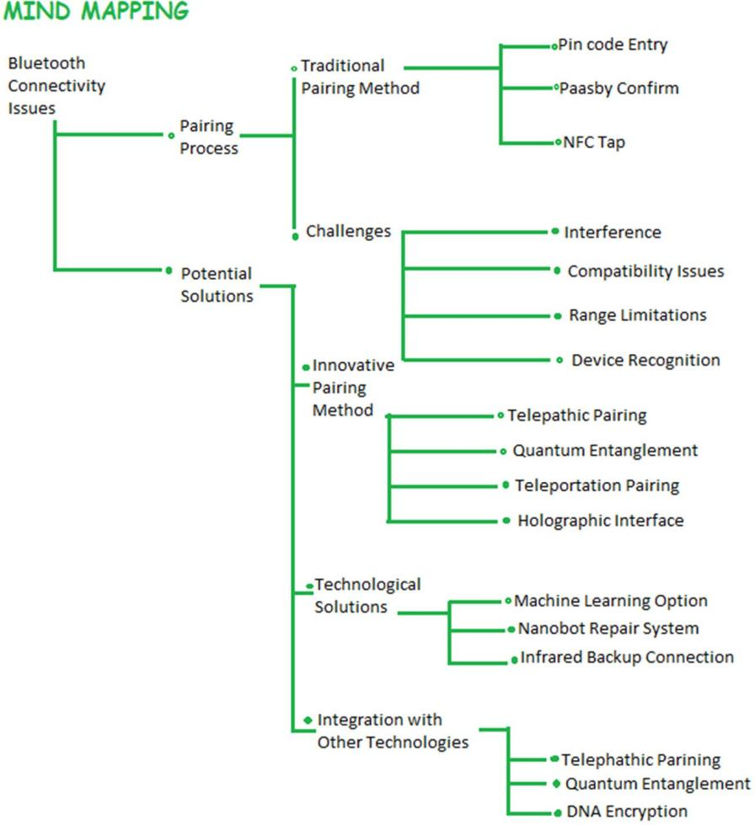

* **Electromagnetic Field mapping:** Create a device to map interference and adjust Bluetooth frequencies accordingly.
* **Holographic Networking:** Use holographic projection for virtual device connections.
* **Nanotechnology:** Embedded nanoscale transmitters for robust Bluetooth connection.

## SCAMPER TECHNIQUE:

is a powerful tool for generating innovative ideas.

## Substitute: ‐

* + Substitute traditional Bluetooth technology with a news, more advanced version.
  + Substitute Bluetooth with an alternative wireless communication technology such as LIFI.

## Combine: ‐

* + Combine Bluetooth with rear Field communication for quicker and more reliable pairing.
  + Combine Bluetooth with AI to automatically troubleshoot and fix connection issues.

## Adapt: ‐

* + Adapt Bluetooth protocols to be more adaptive to different environment conditions.
  + Adapt Bluetooth to work seamlessly with other wireless technologies like Wi‐Fi.

## Modify: ‐

* + Modify Bluetooth antennas and transmitters for better range and signal strength.
  + Modify Bluetooth software to allows for easier manual connection when automatic fails.

## Put to another use: ‐

* + Use Bluetooth connectivity for more than just audio, like data transfer and device synchronization.
  + Utilize Bluetooth becomes for indoor navigations and location – based services.

## Eliminate: ‐

* + Eliminate the need for manual pairing by implementing automatic connection protocols.
  + Eliminate interference by using a frequency – hopping spread sputum technique.

## Reverse / Rearrange: ‐

* + Reverse the connection process by mating devices automatically search for available connections.
  + Rearrange Bluetooth protocols to prioritize connection stability over data transfer speed.

# PRACTICAL 5

## AIM: Prototyping Session:

Have participants select one or more ideas and create a low‐fidelity prototype to test their assumptions and validate their ideas.

Introduction

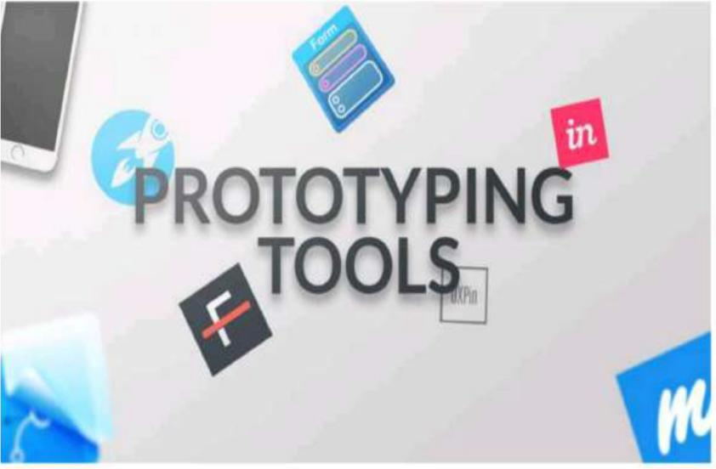Prototyping is the process of creating an early model or simulation of a product, system, or concept to test and refine its functionality, design, and usability. It helps visualize ideas, identify potential issues, and gather feedback from stakeholders before full‐scale development begins. Prototypes can range from simple sketches and wireframes to interactive

digital models or physical mockups. This iterative process saves time and resources by addressing challenges early. Prototyping is widely used in industries like software development, product design, and engineering to ensure the final product meets user needs and expectations.

***Understanding Prototyping***

## Defining Prototyping

* + **Definition of Prototype**: A prototype is a preliminary model or representation of a product used to visualize and test its functionality and design.
  + **Purpose of Prototyping**: The purpose of prototyping is to identify and resolve design flaws, gather user feedback, and refine ideas before final development.
  + **Types of Prototypes**: Types of prototypes include low‐fidelity (sketches, wireframes), high‐fidelity (interactive digital models), and physical prototypes for tangible products.

## Importance of Prototyping

* + **Iterative Development**: Prototyping enables iterative development by allowing continuous testing and improvement of the design based on feedback.
  + **Risk Mitigation**: It reduces risks by identifying potential issues and refining solutions early in the development process.
  + **Enhanced Collaboration**: Prototyping fosters collaboration among stakeholders by providing a tangible model to align ideas and expectations.

## Prototyping Process

* + **Stages of Prototyping**: The prototyping process typically involves ideation, creation, testing, and refining stages to develop effective solutions.
  + **User‐Centered Design**: Prototyping supports user‐centered design by incorporating user feedback to ensure the product meets their needs and preferences.
  + **Agile Development**: Prototyping aligns with agile development by promoting quick iterations and adaptability throughout the design process.

## Benefits of Prototyping

* + **Effective Problem‐Solving**: Prototyping facilitates effective problem‐solving by identifying and addressing design flaws early.
  + **Reduced Time to Market**: It accelerates development by refining concepts quickly and reducing delays in the production process.
  + **Cost‐Efficient Innovation**: Prototyping minimizes costs by testing ideas early, avoiding expensive errors during full‐scale development.

***Enhancing Communication Through Prototyping***

## Visualizing Ideas

* + **Tangible Relationship**: Using physical models to create a direct, hands‐on connection between ideas and their real‐world implications.
  + **Facilitating Feedback**: Prototypes enable clear, focused discussions, inviting constructive critique to refine concepts.
  + **Storytelling Through Prototypes**: Demonstrating ideas through prototypes conveys their narrative, purpose, and potential impact.

## User‐Centric Design

* + **Empathy Through Prototypes**: Prototypes help designers deeply understand user needs by simulating real‐world experiences.
  + **Iterative User Feedback**: Regular user input during design iterations ensures solutions stay relevant and effective.
  + **Aligning Stakeholders**: Prototypes create a shared vision, fostering collaboration and alignment among all stakeholders.

## Mitigating Misinterpretation

* + **Clarity in Communication**: Visualizing ideas through prototypes reduces misunderstandings by making concepts tangible.
  + **Iterative Demonstration**: Repeatedly showcasing evolving designs ensures alignment and minimizes misinterpretation.
  + **Addressing Ambiguity**: Prototypes uncover uncertainties early, enabling precise resolution and shared understanding.

## Building Consensus

* + **Alignment of Vision**: Prototypes unify diverse perspectives by creating a shared, tangible representation of ideas.
  + **Conflict Resolution**: Hands‐on models encourage constructive dialogue, helping to mediate and resolve disagreements.
  + **Empowering Decision‐Making**: Prototypes provide clarity and confidence, enabling informed and collaborative decisions.

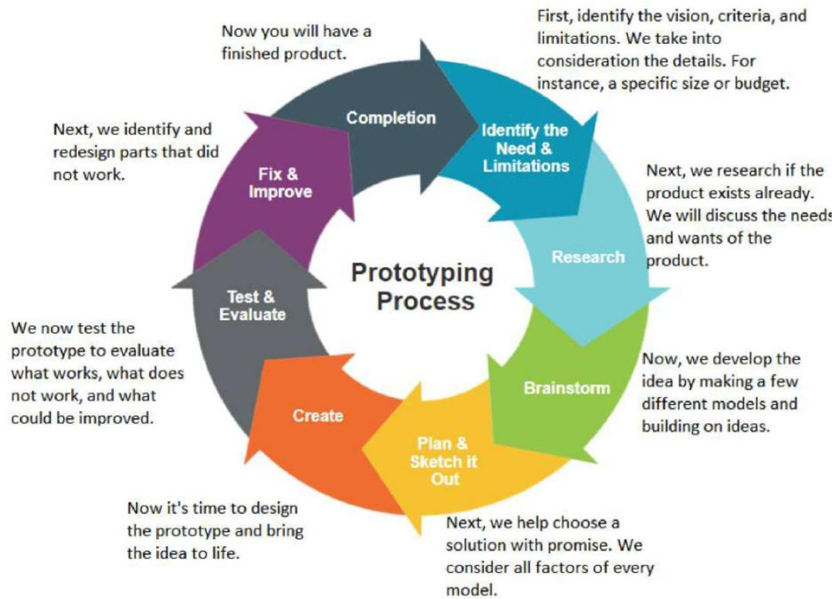

***Tools for Effective Prototyping***

## Low‐Fidelity Prototyping Tools

* + **Paper Prototyping**: Quick and cost‐effective sketches allow rapid iteration and exploration of design ideas.
  + **Wireframing Software**: Digital tools like Figma or Balsamiq create structured, low‐detail layouts for early design feedback.

## High‐Fidelity Prototyping Tools

* + **Interactive Prototyping Platforms**: Tools like Adobe XD or InVision create polished, clickable prototypes for realistic user experiences.
  + **Code‐Based Prototyping**: Writing actual code delivers highly functional prototypes using HTML, CSS and Java Script for accurate testing and validation.

## Collaborative Prototype Environments

* + **Cloud‐Based Collaboration**: Platforms like Figma or Marvel or Miro enable real‐time teamwork and seamless sharing across locations.
  + **Version Control Systems**: Tools like Git (GitHub) ensure organized, trackable changes, preventing conflicts during prototype development.

## User Testing and Feedback Tools

* + **Usability Testing Platforms**: Tools like UserTesting or Maze facilitate remote user testing to gather actionable insights.
  + **Feedback Aggregation Tools**: Solutions like Loopback, UserZoom, Trello or Airtable organize and prioritize user feedback for efficient iteration.



## Exercise:

A prototype is a preliminary version of a product or system that is used for testing, evaluation and experimentation. It can range a simple mock or sketch to a more reddened representation of the final product. Depending on the stage of development and goals of prototyping process.

Prototype and created to:

1. Test Assumption
2. Gather Feedback
3. Iteration Quickly
4. Reduce Risk

Types of Prototypes:

1. Low Fidelity: Suitable for the early stage of the process
2. Medium Fidelity: Suitable for the last stage of prototype model

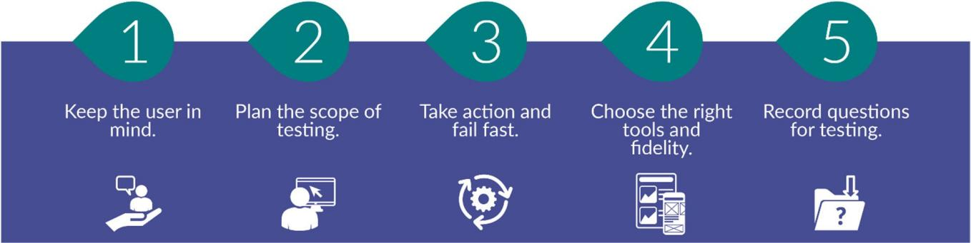

## Low fidelity Prototypes: Telepathic Pairing Device

**Objective:** Design a low fidelity prototype for a telepathic pairing device that eliminates the need for manual Bluetooth pairing by using brainwave technology.

## Material needed:

Two paper cups, string, LED, battery, Aluminium foils.



## Steps:

* + Poke a small hole in the bottom of each paper cup
  + Thread the string through the holes in the cups and tie knouts to keep them in place.
  + The represents the telepathic connection.
  + Attach an LED to the end of the string inside each cups.
  + Make two brainwave sensor using aluminium foil.
  + Attach one end of a wire to the aluminium foil and the other end to a battery.
  + When user holds the aluminium foils, it completes the circuit allowing the LED to the lights up.

When two users touch the aluminium foil with their figures completing this circuit , the LED light up indicating successful telepathic pairing.

## Medium Fidelity: Suitable for the last stage of prototype model

**Materials needed:** Audio EEG sensor Bluetooth module , LED Lights , Breadboard and Jumper wires , power source

## Steps :

* + **Setup and connection:** connect the EEG sensor and Bluetooth module to the microcontroller using jumpers wires and a bread.
  + **Programming:** write a program to read brainwave data from the EEG sensor and interpret it for pairing process. Program the Bluetooth module to send pairing signal to nearby device.
  + **Enclosure design:** design a simple enclosure using 3D printer or cardboard to house the components ensure there are opening for the sensor LED lights and any necessary buttons or switches.
  + **Pairing process:** when the user concentrates on a specific thought the EEG sensor detects the brainwave pattern and sends a pairing signal via Bluetooth to nearby devices. LED lights provide feedback to the users during the pairing process.

## Outcomes :

The low fidelity prototype demonstrates the concept of telepathic pairing for Bluetooth device using simple materials, providing a tangible representation of the innovation idea.

The middle fidelity prototype demonstrates the feasibility of using brainwave technology for Bluetooth pairing, providing a more polished and functional representation of the innovation idea compared to the low fidelity prototype.